**HTML CODE:**

<!DOCTYPE html>

<html>

<head>

<title>Ayush_Rawat MCA-B 26</title>

</head>

<body>

<p>All primes between 2 and 250 are: </p>

<div id="output"></div>

<script>

primes = []

for (let i = 2; i <= 250; i++) {

let isPrime = true;

for (let j = 2; j <= Math.sqrt(i); j++) {

if (i % j == 0) {

isPrime = false;

break;

}

}

if (isPrime) {

primes.push(i);

}

}

document.getElementById("output").innerHTML = primes.join(", ");

</script>

</body>

</html>

**OUTPUT:**

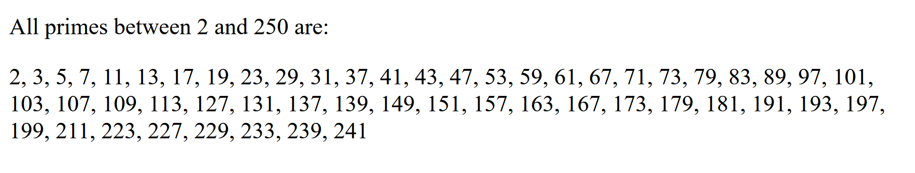

**HTML CODE:**

<!DOCTYPE html>

<html>

<head>

<title>Ayush_Rawat MCA-B 26</title>

</head>

<body>

<p id='words'></p>

<p id='characters'></p>

<p id='vowels'></p>

<p id='consonants'></p>

<script>

const inputString = prompt("Enter a string:");

let numWords = 0;

let numChars = 0;

let numVowels = 0;

let numConsonants = 0;

if (inputString) {

numWords = 1;

for (let i = 0; i < inputString.length; i++) {

let ch = inputString[i].toLowerCase();

if (ch == ' ') {

numWords++;

}

if (ch == 'a' || ch == 'e' || ch == 'i' || ch == 'o' || ch == 'u') {

numVowels++;

} else if (ch >= 'a' && ch <= 'z') {

numConsonants++;

}

numChars++;

}

}

let words = `Number of words: ${numWords}`;

let characters = `Number of characters: ${numChars}`;

let vowels = `Number of vowels: ${numVowels}`;

let consonants = `Number of consonants: ${numConsonants}`;

document.getElementById('words').innerHTML = words;

document.getElementById('characters').innerHTML = characters;

document.getElementById('vowels').innerHTML = vowels;

document.getElementById('consonants').innerHTML = consonants;

</script>

</body>

</html>

**OUTPUT:**



Number of words: 2

Number of characters: 12

Number of vowels: 3

Number of consonants: 7



Number of words: 5

Number of characters: 21

Number of vowels: 5

Number of consonants: 10

**HTML CODE:**

<!DOCTYPE html>

<html>

<head>

<title>Ayush_Rawat MCA-B 26</title>

</head>

<body>

<button onclick="openWindow()">Open New Window</button>

<script>

function openWindow() {

let newWindow = window.open("", "Test", "height=400,width=400");

newWindow.document.write('<h1>test</h1>');

let closeWindow = confirm("Do you want to close the window?");

if (closeWindow) {

newWindow.close();

}

}

</script>

</body>

</html>

**OUTPUT:**

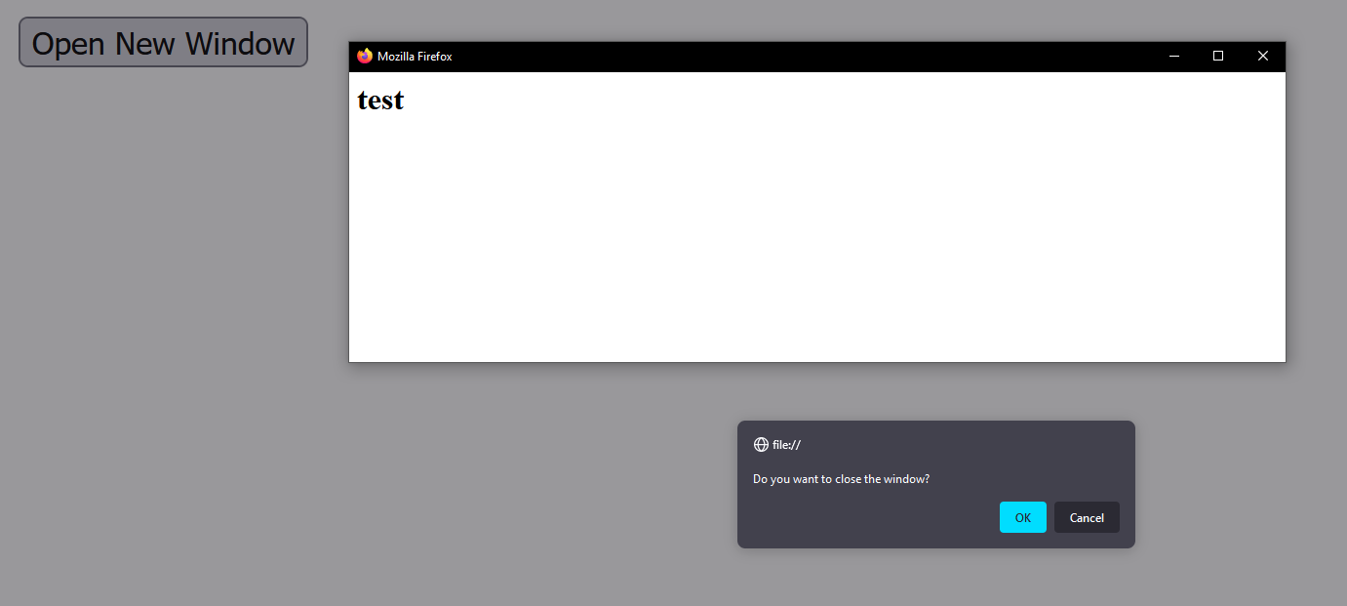

**HTML:**

<!DOCTYPE html>

<html>

<head>

<title>Ayush_Rawat MCA-B 26</title>

<style>

.highlight {

color: red;

background-color: yellow;

font-size: 24px;

}

#output {

border: solid black 5px;

padding: 30px;

}

</style>

</head>

<body>

<form id="inputForm">

<label for="inputText">Enter some text:</label><br>

<textarea name="" id="inputText" cols="30" rows="10"></textarea><br>

<input type="submit" value="Submit">

</form>

<p>

The following is the text entered in the textbox above but font is colored red and background color is yellow. :)

<br>

<div id="output" style='white-space:pre'></div>

</p>

<script>

document.getElementById('inputForm').addEventListener('submit', function(event) {

event.preventDefault();

var input = document.getElementById('inputText').value;

var output = '<span class="highlight">' + input + '</span>';

document.getElementById('output').innerHTML = output;

});

</script>

</body>

</html>

**OUTPUT:**

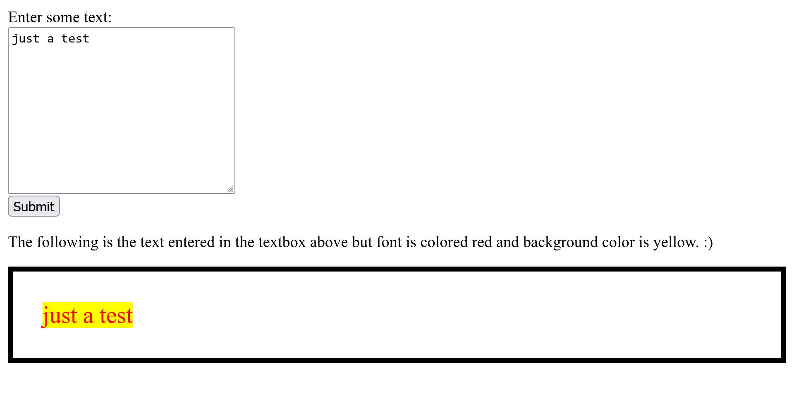

**HTML:**

<!DOCTYPE html>

<html lang="en">

<head>

<meta charset="UTF-8">

<meta http-equiv="X-UA-Compatible" content="IE=edge">

<meta name="viewport" content="width=device-width, initial-scale=1.0">

<title>Ayush_Rawat MCA-B 26</title>

</head>

<body>

<form id="registrationForm">

<label for="name">Name:</label><br>

<input type="text" id="name" name="name"><br>

<span id="nameError" style="color:red"></span><br>

<label for="age">Age:</label><br>

<input type="text" id="age" name="age"><br>

<span id="ageError" style="color:red"></span><br>

<input type="submit" value="Submit">

</form>

<script>

document.getElementById('registrationForm').addEventListener('submit', function (event) {

event.preventDefault();

var name = document.getElementById('name').value;

var age = document.getElementById('age').value;

var isValid = true;

if (!name || !age) {

isValid = false;

alert('All fields are required');

}

if (isNaN(age) || age < 18) {

isValid = false;

document.getElementById('ageError').innerHTML = 'Age must be a number greater than 18';

} else {

document.getElementById('ageError').innerHTML = '';

}

if (/[^a-zA-Z]/.test(name)) {

isValid = false;

document.getElementById('nameError').innerHTML = 'Name must contain only letters';

} else {

document.getElementById('nameError').innerHTML = '';

}

if (isValid) {

this.submit();

}

});

</script>

</body>

</html>

**OUTPUT:**

